

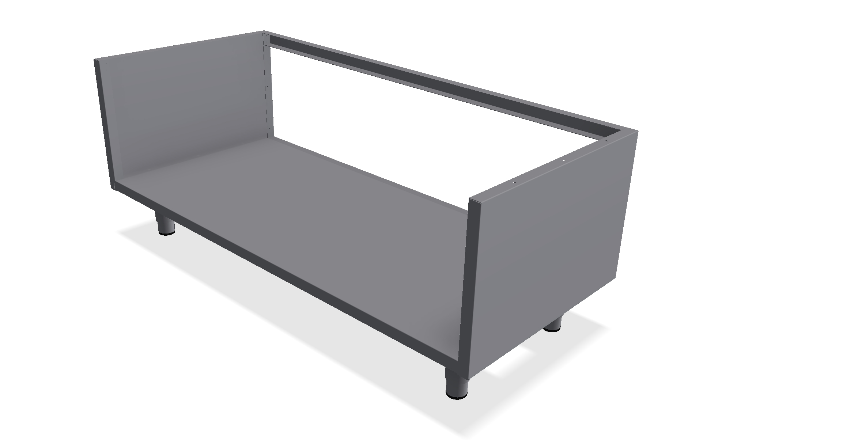
Bain Marie VRBU

Six std. lengths, 1-6 gastronorms
All parts in stainless steel
With under shelf
Hygienic finish

Technical information VRBU

Modell  Model | Artikkelnummer  Item number | Mål  Dimension | Vekt netto/brutto  Weight net/gros | Transport volum  Transport volume
VRBU 400 | 09120400 | 400 x 610 x 550 mm | 17 / 22 kg | 0,19 m³
VRBU 800 | 09120800 | 800 x 610 x 550 mm | 21 / 26 kg | 0,35 m³
VRBU 1100 | 09121100 | 1100 x 610 x 550 mm | 26 / 31 kg | 0,51 m³
VRBU 1400 | 09121400 | 1400 x 610 x 550 mm | 31 / 36 kg | 0,67 m³
VRBU 1700 | 09121700 | 1700 x 610 x 550 mm | 37 / 42 kg | 0,73 m³
VRBU 2025 | 09122025 | 2025 x 610 x 550 mm | 43 / 49 kg | 0,89 m³

TD-500910 - Rev. 21. des. 2015 -GS.

For more drawings and documentation visit our webside: www.rustfriebergh.no

Sertifisert av 

