

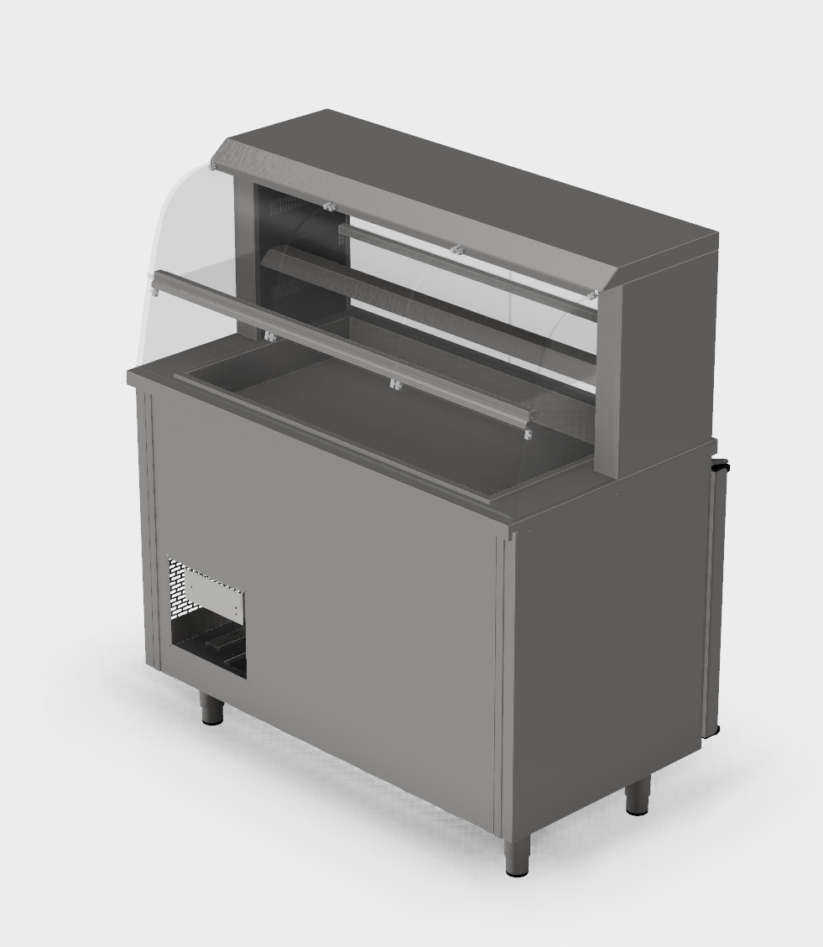
Cold display RBK-2 plan

Display in glass gives a very good exposure
Glass helves give flexible application
Advanced air flow in display
Good lightening
Very good refrigertion capacity
GN fitted in display and cabinet
Hygienic execution
Automatic defrosting
Automatic evaporating of the condensing water

Teknisk informasjon RBK-2 plan

RBK-2 plan is a serving disk designed to maintain a satisfactory serving temperature in an
already cooled product.
RBK-2 plan is not intended for refrigeration or storage of foodstuffs
Temperatur i monter/display 4-7 C.
Temperatur i skap/counter 2-4 C.

Modell  Model | Artikkelnummer  Item number | Mål  Dimension | Vekt netto/brutto  Weight net/gros | Transport volum  Transport volume
RBK-800-2 plan | 10200800 | 802 x 650 x 1377 mm | 150 / 164 kg | 1,13 m³
RBK-800-2 plan S | 10200800 | 802 x 650 x 1377 mm | 130 / 144 kg | 1,13 m³
RBK-1200-2 plan | 10201200 | 1202 x 650 x 1377 mm | 189 / 203 kg | 1,68 m³
RBK-1200-2 plan S | 10201200 | 1202 x 650 x 1377 mm | 169 / 183 kg | 1,68 m³
RBK-1600-2 plan | 10201600 | 1602 x 650 x 1377 mm | 214 / 230 kg | 2,23 m³
RBK-1600-2 plan S | 10201600 | 1602 x 650 x 1377 mm | 194 / 210 kg | 2,23 m³
RBK-2000-2 plan | 10202000 | 2002 x 650 x 1377 mm | 245 / 265 kg | 2,65 m³
RBK-2000-2 plan S | 10202000 | 2002 x 650 x 1377 mm | 224 / 245 kg | 2,65 m³
S= sentralkjøling / central cooling.

Modell  Model | Dører  Doors | Kapasitet i monter  Capasity in display | Brønn i topplate  Capasity well in top plate
RBK-800-2 plan | 1 | 4 x 1/1 GN | 2 x 1/1 GN - 100 mm
RBK-800-2 plan S | 1 | 4 x 1/1 GN | 2 x 1/1 GN - 100 mm
RBK-1200-2 plan | 2 | 6 x 1/1 GN | 3 x 1/1 GN - 100 mm
RBK-1200-2 plan S | 2 | 6 x 1/1 GN | 3 x 1/1 GN - 100 mm
RBK-1600-2 plan | 3 | 8 x 1/1 GN | 4 x 1/1 GN - 100 mm
RBK-1600-2 plan S | 3 | 8 x 1/1 GN | 4 x 1/1 GN - 100 mm
RBK-2000-2 plan | 4 | 10 x 1/1 GN | 5 x 1/1 GN - 100 mm
RBK-2000-2 plan S | 4 | 10 x 1/1 GN | 5 x 1/1 GN - 100 mm

Modell  Model | Strømart  Kind of current | Kjøleeffektbehov ved sentralkjøling  Power requirement central cooling
RBK-800-2 plan | 230 V - 1 – 50/60 HZ – 750 W
RBK-800-2 plan S | 230 V - 1 – 50/60 HZ – 250 W | 750 W /-10
RBK-1200-2 plan | 230 V - 1 – 50/60 HZ – 750 W
RBK-1200-2 plan S | 230 V - 1 – 50/60 HZ – 250 W | 750 W /-10
RBK-1600-2 plan | 230 V - 1 – 50/60 HZ – 850 W
RBK-1600-2 plan S | 230 V - 1 – 50/60 HZ – 250 W | 850 W /-10
RBK-2000-2 plan | 230 V - 1 – 50/60 HZ – 850 W
RBK-2000-2 plan S | 230 V - 1 – 50/60 HZ – 250 W | 850 W /-10
TD-501024 - Rev. 08. des. 2015 -GS.

Sertifisert av 

Tegninger og øvrig dokumentasjon finnes på våre nettsider www.rustfriebergh.no

